

**Synopsis On**

**“DrugDex”**

**Submitted By**

**Nilesh Gajanan Mate**

**Lavanya Sagar Bhoyar**

B.C.A Semester-III

**Under the Guidance of**

**Prof. Atul Thaware**

**Session – 2024-2025**

**SCHOOL OF ALLIED SCIENCES**

**FACULTY OF SCIENCE & TECHNOLOGY**

Sawangi (Meghe), Wardha- 442107, Maharashtra, India

[www.dmiher.edu.in](http://www.dmiher.edu.in)

**CONTENTS**

1. **Introduction**
2. **Problem Statement**
3. **Objective of the project /Scope of the Project**
4. **Literature Review (Optional)**
5. **Proposed Methodology**
6. **Flow Diagram**
7. **Application**
8. **Expected Outcomes**
9. **Timeline**
10. **Resources Required**
11. **Results/Conclusion**
12. **Future Scope**
13. **References**

**Introduction**

In today's world, healthcare is one of the most critical sectors affecting the lives of billions of people. However, with the increasing complexity of medications and treatments, many consumers are often left uninformed about the drugs they are prescribed. While doctors provide medical advice and prescriptions, patients tend to lack a deeper understanding of the medications they are consuming. This knowledge gap may lead to confusion, misuse, or even non-compliance with prescribed treatments.

DrugDex aims to address this gap by offering a user-friendly platform where consumers can access clear and comprehensive information about medications. Unlike platforms that target healthcare professionals or pharmacy students, DrugDex is designed for the general public, making it easier for everyday users to find relevant information about the drugs they take. With a focus on user experience, DrugDex empowers consumers to understand the composition, potential side effects, usage, and manufacturers of various medications. This, in turn, helps patients make more informed decisions regarding their health.

The rise of digital technologies presents a unique opportunity to educate and inform the public about health-related topics. As more people turn to the internet for health advice, there is a need for reliable and accessible platforms. DrugDex seeks to fill this gap by offering a trustworthy source of information that is tailored specifically to the needs of the general public.

**Problem Statement**

The core problem that DrugDex seeks to solve is the lack of accessible, accurate, and easy-to-understand information regarding medications. When a person is prescribed a drug, they often receive minimal information from healthcare providers about what the drug does, its side effects, its composition, or its manufacturer. In many cases, patients have to rely on search engines to find this information, leading them to potentially unreliable sources.

A lack of understanding can lead to several issues, including improper use of medications, fear of side effects, or worse, non-compliance with prescribed treatments. Consumers, especially those who may not have a background in medicine or pharmacy, need a resource that simplifies this complex information and makes it easily accessible. DrugDex solves this problem by providing a dedicated platform that delivers trustworthy and easy-to-understand drug information.

By targeting the general public, DrugDex eliminates the technical jargon commonly found in other platforms and presents information in a way that resonates with non-experts. The goal is to offer an educational experience that leads to better health outcomes for patients who understand the medications they are consuming

**Objective of the Project / Scope of the Project**

The objective of DrugDex is clear: to provide consumers with detailed, easy-to-access, and reliable information about the medications they are prescribed. This includes comprehensive details such as the name of the drug, its composition, uses, side effects, manufacturer, and reviews.

**Scope of the project:**

* **Search Functionality**: Users can search for medicines by name, ingredient, or use. The search bar will provide a fast and intuitive way for users to access the data they need.
* **Medicine Information Database**: The platform will house a large database of medicines, storing details like composition, uses, side effects, and reviews.
* **User-Friendly Interface**: The website will be designed with a focus on simplicity, ensuring that users, regardless of their technical abilities, can easily navigate and find the information they need.
* **Reviews and Feedback**: Users will have access to reviews that indicate the percentage of excellent, average, and poor experiences from other consumers.

The platform will not only serve the current need but also has the potential to expand into other areas of healthcare information, such as interactions between medicines, contraindications, and even the inclusion of alternative medicines.

**Literature Review.**

There is a wealth of literature that explores the importance of patient education in improving health outcomes. Studies have consistently shown that patients who are more informed about their treatments tend to comply better with prescriptions, experience fewer adverse effects, and report higher levels of satisfaction with their healthcare experience.

Existing platforms like WebMD and Drugs.com offer extensive information about medications, but they often cater to healthcare professionals or pharmacy students, presenting highly technical data that may overwhelm the general consumer. These platforms focus on clinical details and may not always consider the general public's need for simple explanations.

Research also indicates that many people seek out information about their health conditions and medications online. However, the reliability of the information they find is often questionable. This is a major concern, as misinformation can lead to dangerous outcomes. Platforms like DrugDex aim to fill this gap by providing consumers with vetted, accurate, and understandable information.

One area that has been highlighted in various studies is the need for user-friendly design in health information systems. People prefer platforms that are easy to navigate, visually appealing, and provide straightforward access to information. This is especially important for the elderly and individuals who may not be well-versed in using technology.

**Proposed Methodology**

To ensure the successful development and implementation of the DrugDex platform, the following methodology will be followed:

* **Requirement Gathering**: Understanding the needs of the target audience and defining the features that will be implemented on the platform.
* **Front-End Development**: The front-end will be built using HTML, CSS, and JavaScript, ensuring a responsive and intuitive design. A modern user interface will be created to provide seamless navigation for users.
* **Back-End Integration**: Firebase will be used for back-end services, including storing and retrieving information about various medicines. Firebase will be responsible for housing the data, managing user interactions, and handling user authentication if needed.
* **Search Functionality**: The search functionality will be implemented using JavaScript. Users will be able to search for drugs by name or keyword, and the results will be fetched from the database (Firebase or local JSON, depending on implementation) and displayed on the website.
* **Testing and Quality Assurance**: Rigorous testing will be conducted to ensure the website functions properly across different devices, browsers, and operating systems. The goal is to ensure that the website remains stable, fast, and responsive even with large datasets.
* **Launch and Deployment**: After testing, the platform will be deployed for public use. Feedback will be gathered from users for future improvements.

**Flow Diagram**

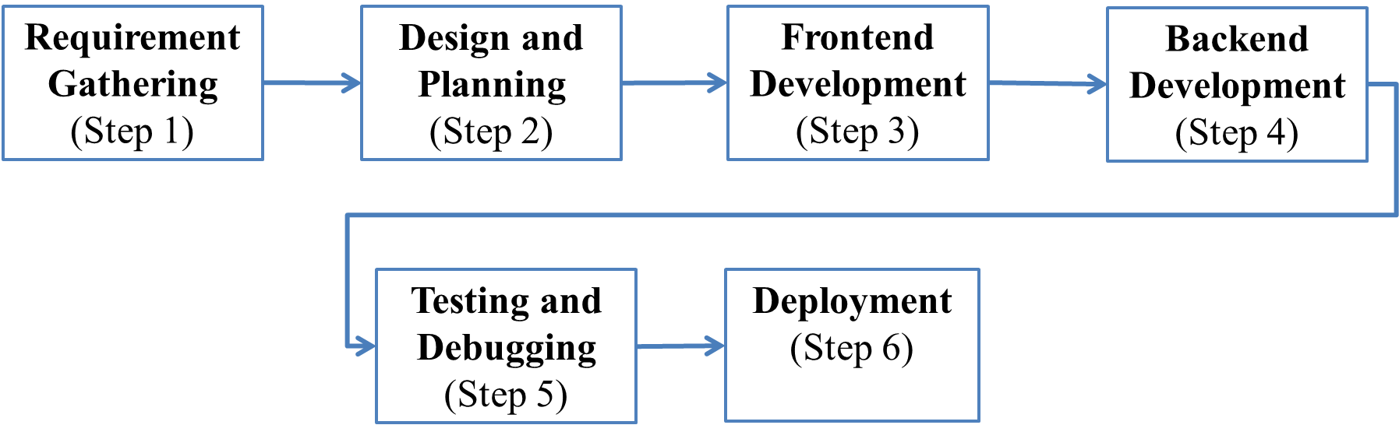

**Application**

The application of DrugDex goes beyond merely providing information. It serves as a tool for educating the public about their health and treatments. The following are key applications of the project:

* **Consumer Education**: Help the general public make informed decisions about the medications they take.
* **Accessible Healthcare Information**: Offer a platform that can be accessed anytime and anywhere, providing reliable drug information.
* **Better Healthcare Compliance**: Informing patients of side effects and uses can lead to better compliance with treatment plans.
* **Medical Research Tool**: DrugDex could also serve as a resource for students, caregivers, and researchers interested in learning about pharmaceutical drugs.

**Expected Outcomes**

At the end of this project, the following outcomes are anticipated:

* A user-friendly, accessible website that provides detailed information about medicines, tailored for the general public.
* A well-organized, searchable database containing information on medicine names, compositions, uses, side effects, and manufacturers.
* A responsive and visually appealing user interface.
* Positive user feedback indicating an improved understanding of the medications they consume.
* Increased awareness among consumers about the safety and efficacy of the drugs they are taking.

**Timeline**

The project timeline is as follows:

* **Weeks 1–2**: Initial research, project planning, and gathering of relevant drug information.
* **Weeks 3–4**: Front-end development, designing the layout, and implementing basic user interface features.
* **Weeks 5–6**: Back-end integration with Firebase, setting up the database, and testing functionality.
* **Weeks 7–8**: Implementing search functionality and conducting internal testing.
* **Week 9**: User feedback collection and adjustments to the platform based on feedback.
* **Week 10**: Final testing and launch of the website.

**Resources Required**

* Firebase account for back-end database and storage.
* HTML, CSS, and JavaScript for front-end development.
* JSON file for medicine data.
* Development and testing tools (VS Code, browsers, and devices).
* Access to reliable sources for drug information.
* Time and effort from developers and testers to ensure the success of the project.

**Results/Conclusion**

At the conclusion of this project, DrugDex will provide users with a comprehensive and easy-to-use platform that allows them to access drug information quickly and easily. This project will demonstrate how healthcare information can be made more accessible to the general public through the use of technology. The expected results are a reliable, well-functioning website that not only helps patients make better-informed decisions but also contributes to overall healthcare literacy.

**Future Scope**

* **Mobile App Development**: Develop a mobile application for DrugDex to expand its reach to more users.
* **Multilingual Support**: Provide information in various languages, making the platform accessible to a wider audience.
* **Integration with Pharmacies**: Collaborate with pharmacies to provide real-time availability and pricing information for medicines.
* **Interactive Features**: Adding features like live chats with healthcare professionals or AI-based drug interaction checkers.
* **User-Generated Reviews**: Allowing users to submit their own reviews and experiences with medications.

**References**

1. WebMD: [www.webmd.com](http://www.webmd.com)
2. Drugs.com: [www.drugs.com](http://www.drugs.com)
3. Firebase Documentation: <https://firebase.google.com/docs>

**Guide Name : Prof.Atul Thaware**

**Guide’s Sign :____________**

**Student’s Name : Nilesh Gajanan Mate**

**Student’s Sign :____________**

**Student’s Name : Lavanya Sagar Bhoyar**

**Student’s Sign :____________**